Challenge: Sumo-Bots
In this challenge, you will design and build a Sumo-Bot which you will program to battle an opponent in a wrestling match. To successfully complete this challenge, your robot must meet design specifications (including the use of at least 2 sensors), enter the arena initially, re-enter the arena when it encounters a border, and win at least one match (or survive half the match for partial credit). To win a match, you must defeat your opponent by pushing it out of the arena or disabling it. The overall challenge winner will be determined in a double-elimination competition.
Challenge Specifics:
- This event will take place on a ~4’x4’ whiteboard with a black border. The arena will be a white square 36” on a side. The arena will be slightly elevated to facilitate timely conclusion of matches.
- Sumo-bot wrestling will begin with opponents in opposite corners and will continue until either one opponent is completely out of the arena (pushed or otherwise), or one Sumo-bot is disabled.
- The match will begin with a countdown, followed by the student pressing the “Run” button on the brick. After pressing “Run”, the student must step away and cannot touch their bot until the challenge is over.
  - All students must stand away from the sumo arena for the duration of the match.
- If, after two minutes, there is no clear winner, the competition will be halted. An additional one minute re-match will begin.
  - For the rematch, Sumo-bots will be placed back-to-back in the center of the arena and must move forward or turn (may not move backwards) immediately after the start of the match.
  - If there is no clear winner after the re-match, judges will declare a winner based on which Sumo-bot is least disabled, or has most nearly pushed its opponent from the arena during the matches.
- The winning robot must either push its opponent completely out of the arena (not counting appendages extending beyond 12”), or disable its opponent (render opponent unable to maneuver, while victor Sumo-bot still can).
  - If a robot is not pushed off the mat, but its wheels are no longer in contact with the mat, it is considered flipped. The flipped Sumo-bot is considered disabled and loses the match.
  - If a robot moves itself completely out of the arena, it is disqualified and the opponent wins that match by default.
Design Specifications:
Components: All robots will be constructed only from a single kit and the following additional allowed items:
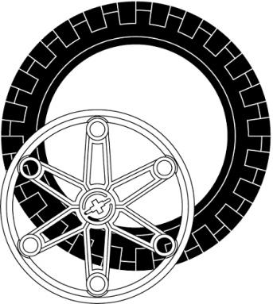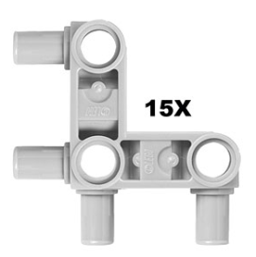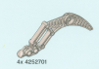

Large Wheel (up to 4) Angled snap Beam (up to 8) Claw (up to 4)
Size: All robots will fit inside a cube 12 inches on a side
Sensors: All robots must use at least TWO sensors.
Design Modifications: Either hardware or software may be modified on the day of competition, provided the robot is ready to compete at its designated time.

Sumo-Bots: Grading
Criteria | Points Possible | Points Earned
Engineering Journal with daily entries including initial sketch, at least 4 problems and their solutions, and detailed drawing of final design | 6
Sumo-Bot meets design specifications | 2
Sumo-Bot enters the arena | 2
Sumo-Bot re-enters the arena | 2
Sumo-Bot wins one match (2 pts)  OR Sumo-Bot survives for 1 minute (1 pt) | 2
BONUS: 1st place +2, 2nd place +1 | varies
TOTAL | 14

